High Level Design

Steel Bar Bundle Inspection System: Image Processing, Object Detection, and OCR Integration

Revision Number: 1.0

Department of AI & Big Data, Woosong University

**Table of Contents**

**Table of Contents……………………………………………………………………………2**

**Revision History…………………………………………………………………………….3**

# Introduction…………………………………………………………………………...4

* 1. Why this High-Level Design?………………….………………………………..4
  2. Scope…………………………………………………………………………….4
  3. Overview………………………………………………………………………...4

# General Description…………………………………………………………………. 4

* 1. Product Perspective…………………………………………………………….4
  2. Tools used………………………………………………………………………4
  3. General Constraints……………………………………………………………..4
  4. Special Design aspects…………………………………………………………….5

# Design Details…………………………………………………………………………….5

* 1. Main Design Features……………………………………………………………….5
  2. Architecture Overview…………………………………………………………..….5
  3. SW Diagram…………………………………………………………………………..6

3.4.1.Description……………………………………………………………………..6

* 1. Reliability and Performance…………………………………………………………..6

**Appendix A: Glossary……………………………………………………………………………..7**

**Revision History**

| **Name** | **Date** | **Reason for changes** | **Version** |
| --- | --- | --- | --- |
| JuSTeel | 2024/04/18 | Formatting | 1.0 |
|  |  |  |  |

# Introduction

* 1. Why this High Level Design Document? :

The purpose of this High Level Design (HLD) Document is to add the necessary detail to the current project description to represent a suitable model for coding. This document is also intended to help detect contradictions prior to coding, and can be used as a reference manual for how the modules interact at a high level.

* 1. Scope:

The document covers the system architecture, including the application architecture, technology stack, database design and user interface aspects.

* 1. Overview:

The system is designed to automatically extract and store information from iron bars using computer vision techniques. It consists of multiple modules that work together to achieve this goal.

2. General Description

2.1. Product Perspective:

The system is designed to automatically extract and store information from images of steel bars

2.2. Tools used:

1. Lucid chart, a web-based diagramming tool that allows users to create various types of diagrams and charts.
2. YOLOv5 used for object detection
3. OpenCV and TensorFlow for video processing
4. Keras is a high-level neural networks API , written in Python used for fast and easy experimentation with deep learning models.

2.3. General Constraints:

The System assumes reliable and static pictures from the CCTV(s)

Maintain minimum 80% detection accuracy for Object Detection, minimum 70 - 90% detection accuracy for Text Detection and minimum 90% detection accuracy for Text Recognition

The user must have the ability to switch multiple camera sources if more than one is added

2.4. Special Design Aspects:

The models are designed for scalable deployment architectures. Allow for model utilization by adapting to varying computational resources.

3. Design Details.

3.1 Main Design Features:

* Real-time video processing and object detection.
* Adaptive detection algorithms
* Database integration for event logging
* Event storing and historical review through a database

3.2. Architecture Overview:

CCTV Module: Data Acquisition and Preprocessing.

Object Detection Module: Processes the video feed and detects individual steel bars.

Text Detection Module: Detects the text regions within the image.

Text Recognition Module: Extracts text information.

Database Module: Data storage.

User Interface: Views the table containing the information.

3.3. SW Diagram:

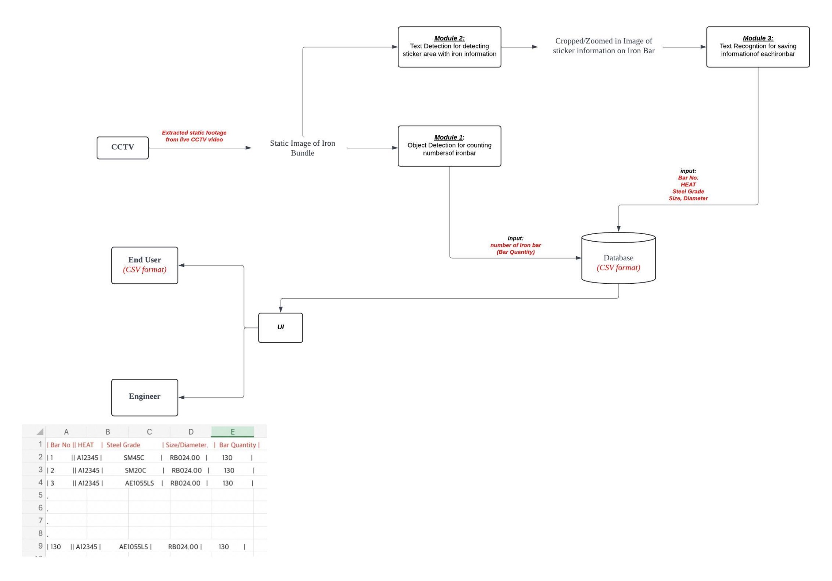

Description:

* CCTV Module: Captures and provides a static image of Iron Bundles, which becomes the input data for Module 1.
* Module 1 detects the individual iron bars using object detection algorithms.
* Module 2 detects the text sticker area on the iron bar.
* Module 3 recognizes and extracts text information.
* Database Module: stores the extracted information and number of detected individual iron bars (from Module 1) in CSV format.
* UI displays the end result in tables.

3.4. Reliability and Performance:

This project is designed for precise detection of material bars and extraction of sticker information, ensuring top-notch quality control at SeAH Besteel's manufacturing site.